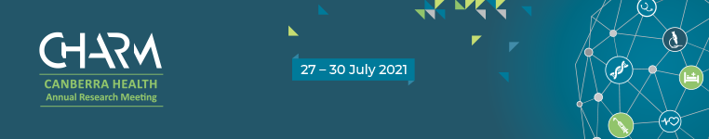
CHARM 2021 – Save the date!

The CHARM program committee are happy to announce that CHARM is back in 2021.

The Canberra Health Annual Research Meeting (CHARM) is hosted by the Centre for Health and Medical Research in the ACT Health Directorate and Canberra Health Services, in collaboration with the region’s university partners, the Australian National University, the University of Canberra, UNSW Canberra, Australian Catholic University and Australian Institute of Sport.

Essential to successful research translation is the communication of research with our stakeholders. CHARM is a three-and-a-half day meeting which includes expert presentations from international and national speakers, local clinicians and scientists, panel discussions and workshops. The meeting seeks to explore how interdisciplinary research can contribute to a sustainable health system through discovery and collaboration.

CHARM facilitates collaboration between health researchers, students, policy makers, carers, consumers, industry and clinicians from a diverse range of health disciplines and is the premier meeting for the communication and translation of health-related research practice in the ACT.

CHARM 2021 will be held as an online conference, 27-30 July. The program committee is pleased to present the exciting program that was developed for CHARM 2020, prior to its cancellation due to Covid-19.

There will be a virtual online poster display as well as the opportunity for researchers to display printed posters at the Canberra Hospital.

Key dates
Monday 12 April – Abstract submissions open
Monday 17 May – Abstract submissions close
Friday 4 June – Notification of submission outcome

Overview of Program
Tuesday 27 July – ACT in profile: big initiatives
Big initiatives from partner universities.
Keynote speaker: Dr Jordan Nguyen – Removing barriers to disability

Wednesday 28 July – Transitions in mental health care
Showcasing the latest research in clinical and service delivery, and technological innovations in mental health care. A panel discussion will conclude the day.
Keynote speaker: Dr Andy Cope – The happiness advantage

Thursday 29 July – ACT research in focus
Medical, allied health, nursing and midwifery sessions.
Keynote speaker: Prof Kim Usher – Psychosocial impact of emergencies and disasters

Friday 30 July – ACT research in focus
3 Minute Thesis, Medical and translational research sessions and Health Analytics Research Collaboration (HARC)
Keynote speaker: A/Prof Barbara Mintzes – Bias in clinical trials research

Contact us
For more information about CHARM 2021, please contact the Centre for Health and Medical Research on
5124 5257 or preclinical.research@act.gov.au

